Programming Fundamentals

Project Report

Objective: Climate Change Impact Calculator

Submitted by:
Leader Name: Wasif Ali Reg. No: 245187
Member Name: Anisa Khan Reg. No: 245215
Member Name: Jawad Mustafa Reg. No: 245195
Member Name: Faiqa Umar Reg. No: 245161
Member Name: Mubashir Ali Reg. No: 245185

Submitted to:

SIR GHULAM ALI

Department of Computer Science
Air University - Aerospace and Aviation Campus, Kamra
Table of Contents

CHAPTER 1: PROBLEM STATEMENT 4
1.1 Statement 4
1.2 Background 4
1.3 Objective 4
1.4 Significance 4
CHAPTER 2: INTRODUCTION 5
2.1 Overview 5
2.2 Motivation 5
2.3 Relevance 5
CHAPTER 3: ALGORITHM AND FLOWCHART 5
3.1 Algorithm 5
3.2 Pseudocode 7
3.3 Flowchart 10
CHAPTER 4: DESIGN AND IMPLEMENTATION 11
4.1 System Design 11
4.2 Modules 13
4.3 Data Structures 13
4.4 Code Implementation 13
CHAPTER 5: TESTING 15
5.1 Test Plan 15
5.2 Test Cases 16
5.3 Results 21
5.4 Error Handling 22
CHAPTER 6: USER INTERACTION FEATURES 22
6.1 Menu Option 22
6.2 File Saving 26
CHAPTER 7: ENVIRONMENTAL INSIGHTS 26
7.1 Carbon Offset Calculation 27
7.2 Comparison Insights 28
CHAPTER 8. CHALLENGES AND LIMITATIONS 28
8.1 Challenges 28
8.2 Limitations 32
CHAPTER 9: CONCLUSION 33
9.1 Summary 33
9.2 Future Work 33
CHAPTER 10. APPENDIX 34
10.1 Full Program Code 34
10.2 Sample Inputs and Outputs 36
10.3 Formulas and Constants 39

CHAPTER 1: PROBLEM STATEMENT

1.1 Statement
Develop a Climate Change Impact Calculator program that estimates the carbon footprint of various human activities. The program will calculate the total CO2 emissions based on user input, provide an Air Quality Index (AQI), suggest methods to offset emissions, and deliver actionable environmental tips. Additionally, the program will:
- Offer detailed reports for individual activities.
- Compare different transportation modes to highlight emission differences.
- Predict future emissions based on current activity levels.
- Save results to a file for future reference.

1.2 Background
Climate change is a defining challenge of our time, with carbon emissions playing a critical role in environmental degradation. The need for accessible tools that educate individuals on their contributions to global emissions has never been greater. This project addresses this gap by offering a tailored solution that combines simplicity, accuracy, and practicality.

1.3 Objective
This program is designed to:
- Accurately calculate carbon footprints from user-input data.
- Provide comparative insights into the environmental impact of different activities, such as transportation and electricity usage.
- Suggest actionable recommendations for reducing emissions and improving sustainability.
- Incorporate predictive analytics to estimate future trends.
- Offer file-saving and report generation for easy reference.

1.4 Significance
The significance of this program lies in its ability to convert data into actionable insights. It encourages individuals to take responsibility for their carbon emissions, fostering a culture of environmental awareness and sustainability. Furthermore, it aligns individual actions with global goals for combating climate change.

CHAPTER 2: INTRODUCTION

2.1 Overview
In an era of increasing environmental concerns, there is a growing need for tools that allow individuals to quantify their carbon footprint and understand the impact of their daily activities on the environment. This program aims to provide a user-friendly solution to calculate and analyze carbon emissions across various activities (e.g., travel, electricity usage) and suggest actionable measures to reduce environmental impact. Additionally, it offers personalized insights such as the Air Quality Index (AQI), carbon offset strategies, and future emission predictions. The results are visualized via a bar chart and saved for further reference.

2.2 Motivation
The motivation behind this project stems from the urgent need to address climate change at the individual level. By providing a tool that combines accessibility and accuracy, this project empowers users to become active participants in mitigating environmental harm. It bridges the gap between awareness and action, enabling users to align their choices with sustainability goals.

2.3 Relevance
This program is relevant in today’s context as it equips users with the knowledge to make environmentally responsible choices. Whether for personal use, corporate accountability, or educational purposes, the program offers valuable insights that align with global efforts to combat climate change.

CHAPTER 3: ALGORITHM AND FLOWCHART

3.1 Algorithm
The Climate Change Impact Calculator follows a structured algorithm
- Start
- Define Constants and Arrays:
  - Set the total number of activities as 5.
  - Create an array of activity names (e.g., "Car travel", "Electricity usage", etc.).
  - Create an array of predefined CO2 emissions for each activity.
  - Create an empty array for user inputs.
- Display Instructions:
  - Show a welcome message and instructions for entering activity data.
- Input User Data:
  - For each activity, ask the user to input the number of units (e.g., kilometers, hours, etc.).
  - Check if the input is valid (numeric); if not, show an error and stop the program.
- Calculate Total Emissions:
  - Multiply each activity's units by its CO2 emission factor and sum them up.
- Determine Air Quality Index (AQI):
  - Use the total emissions to calculate AQI based on predefined ranges.
- Calculate Climate Impact:
  - Compute a "climate change impact factor" using a logarithmic formula.
- Estimate Offsets Needed:
  - Calculate how many trees or solar panels are needed to offset the emissions.
- Show Results:
  - Display activity-wise emissions, total emissions, AQI, climate impact factor, and offset suggestions (trees and solar panels).
- Display Bar Chart:
  - For each activity, calculate its proportional emissions and display a bar chart.
- Show Menu for Further Options:
  - Present a menu with the following options:
    - View detailed climate report.
    - Compare car vs. bus emissions.
    - Get carbon offset suggestions.
    - Learn environmental tips.
    - View all options.
    - Predict future emissions.
- Handle User Choice:
  - Based on the selected option, perform the corresponding action and display the results.
  - Repeat until the user decides to exit.
- Save Report to File:
  - Save the climate impact report and other results in a text file.
- Exit Program:
  - End the program after saving or user exits.
- Stop

3.2 Pseudocode
Here’s the Pseudocode for the Climate Change Impact Calculator
1. START
2. SET total_activities = 5
SET activity_names = ["Car travel", "Electricity usage", ...] // Add other activities
SET emission factors = [CO2_factor1, CO2_factor2, ...] //Predefined CO2 emissions per unit
INITIALIZE user_inputs = [] // Empty array to store user inputs
INITIALIZE total_emissions = 0
3. DISPLAY "Welcome to the Carbon Emission Calculator!"
DISPLAY "Enter the number of units for each activity to calculate emissions."
4. FOR i FROM 0 TO (total_activities – 1)
DO
DISPLAY "Enter the number of units for " + activity_names[i] + ":"
INPUT units
IF units IS NOT NUMERIC THEN
DISPLAY "Invalid input. Please restart the program and enter numeric values."
EXIT
END IF
APPEND units TO user_inputs
END FOR
5. FOR i FROM 0 TO (total_activities – 1)
DO
total_emissions = total_emissions + (user_inputs[i] * emission factors[i])
END FOR
6. SET AQI = CALCULATE_AQI(total_emissions)
7. SET climate_impact = LOGARITHMIC_FORMULA(total_emissions)
8. SET trees_needed = CALCULATE_TREES(total_emissions)
SET solar_panels_needed = CALCULATE_SOLAR_PANELS(total_emissions)
9. DISPLAY "Activity-wise Emissions:"
FOR i FROM 0 TO (total_activities – 1) DO
DISPLAY activity_names[i] + ": " + (user_inputs[i] * emission_factors[i]) + " kg CO2"
END FOR
DISPLAY "Total Emissions: " + total_emissions + " kg CO2"
DISPLAY "Air Quality Index (AQI): " + AQI
DISPLAY "Climate Impact Factor: " + climate_impact
DISPLAY "Offsets Needed: " + trees_needed + " trees or " + solar_panels_needed + " solar panels"

10. DISPLAY_BAR_CHART (activity_names, user_inputs, emission_factors)
11. WHILE TRUE
DO
DISPLAY "Menu Options:"
DISPLAY "1. View Detailed Climate Report"
DISPLAY "2. Compare Car vs. Bus Emissions"
DISPLAY "3. Get Carbon Offset Suggestions"
DISPLAY "4. Learn Environmental Tips"
DISPLAY "5. Predict Future Emissions"
DISPLAY "6. Exit"
DISPLAY "Enter your choice:"
INPUT choice
12.
IF choice == 1 THEN
DISPLAY_DETAILED_REPORT()
ELSE IF choice == 2 THEN
COMPARE_CAR_BUS_EMISSIONS()
ELSE IF choice == 3 THEN
DISPLAY_OFFSET_SUGGESTIONS()
ELSE IF choice == 4 THEN
DISPLAY_ENVIRONMENTAL_TIPS()
ELSE IF choice == 5 THEN
PREDICT_FUTURE_EMISSIONS()
ELSE IF choice == 6 THEN
BREAK
ELSE
DISPLAY "Invalid choice. Please try again."
END IF
END WHILE

13. SAVE_TO_FILE ("climate_impact_report.txt", detailed_report)
14. DISPLAY "Thank you for using the Carbon Emission Calculator! Goodbye."
15. STOP.

3.3 Flowchart
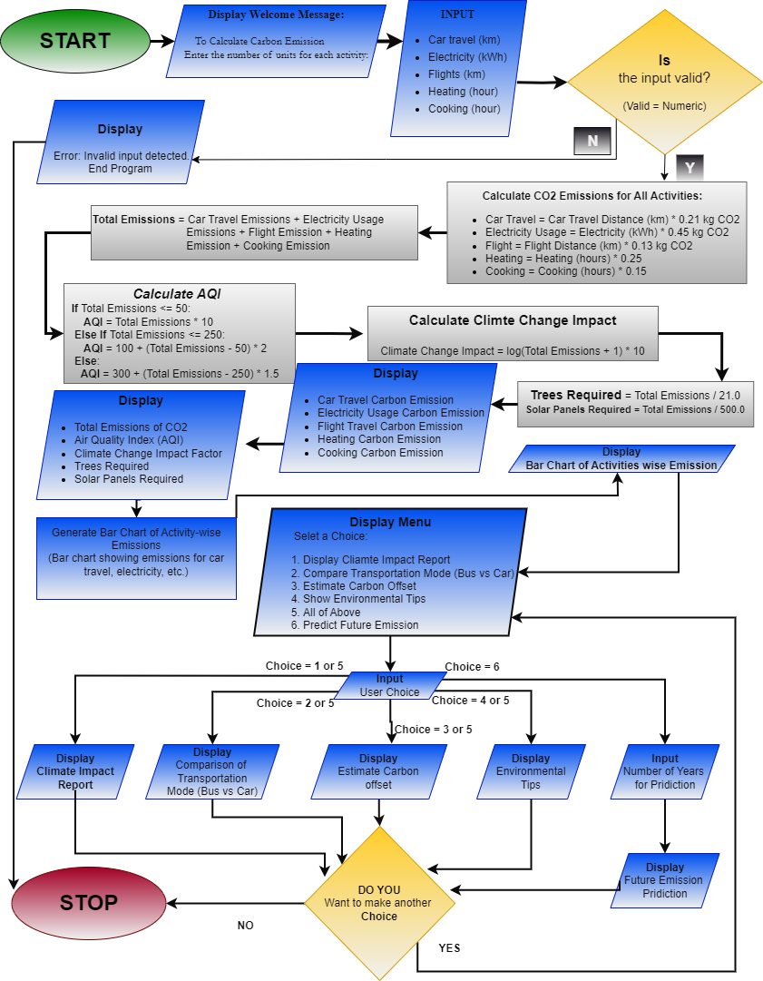

CHAPTER 4: DESIGN AND IMPLEMENTATION

4.1 System Design
The Climate Change Impact Calculator is designed using a modular approach to ensure clarity, scalability, and maintainability. The primary components of the program are:
- Input Module:
- Gathers user input for different activities such as car travel, electricity usage, flights, heating, and cooking.
- Implements robust error handling to ensure only valid numeric inputs are accepted, as shown below:
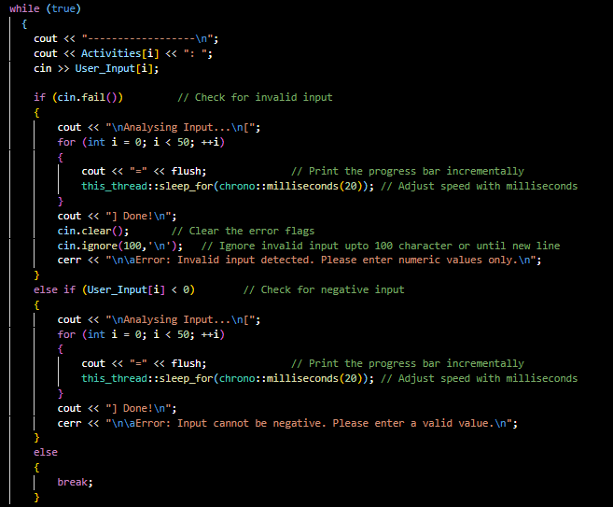
- This ensures the program handles invalid inputs gracefully.

- Processing Module:
- Calculates total emissions for each activity using predefined CO2 emission factors:
- Determines the Air Quality Index (AQI) using a standardized scale with varying ranges:
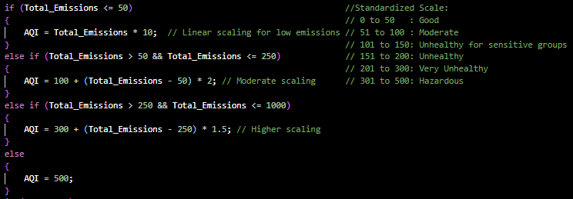
- Calculates carbon offset requirements for trees and solar panels using well-defined formulas:
- Visualization Module:
- Provides a bar chart for activity-wise emissions:
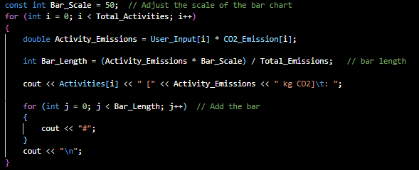
- This helps users visualize which activities contribute the most to emissions.

- File Management Module:
- Saves the results and bar chart to a text file for future reference
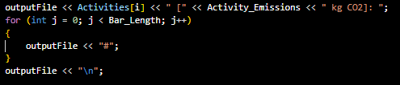

4.2 Modules
The program is divided into the following functional modules:
- Main Menu: Provides options to display reports, compare transportation modes, suggest offsets, give tips, and predict future emissions.
- Calculation: Performs all CO2-related computations using constants and user input.
- Comparison: Compares transportation modes and shows potential emission savings.
- Visualization: Outputs activity-specific emissions and bar charts.
- File Saving: Ensures all data and insights are recorded for later review.

4.3 Data Structures
The program uses arrays for efficient storage and retrieval of activity names, user inputs, and CO2 emission factors:

4.4 Code Implementation
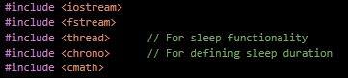
The program is written in C++ for efficient execution, incorporating error handling, modular design, and structured programming principles. Libraries such as <iostream>, <fstream>, <thread>, <chrono> and <cmath> are utilized for input/output operations, file handling, and advanced calculations like logarithms for the Climate Change Impact Factor:
The program utilizes the <thread> and <chrono> headers to implement time delays and simulate progress bars. These features enhance the user experience by providing feedback during calculations and report generation. The <thread> header offers functionality for threading and precise control over execution delays, while <chrono> provides utilities for handling time-related functions such as measuring durations and defining sleep intervals.
Advantages:
- Adds realism to the program by simulating real-time processing.
- Improves user engagement and feedback through progress visualization.
- Provides precise control over time-based operations.
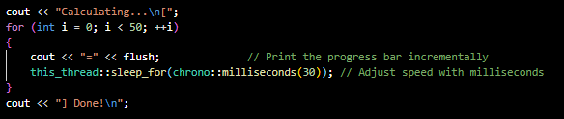

4.4 Bar Chart Visualization
The program includes a bar chart feature to provide a clear and proportional visualization of emissions from various activities. This enhances the user's ability to identify high-emission activities and make informed decisions to reduce their carbon footprint.
Implementation Details:
- Purpose:
  - Helps users understand the contribution of each activity to their total emissions.
  - Highlights which activities have the highest environmental impact.
- Calculation Method:
  - Each activity’s emissions are calculated as:
Activity Emissions= User Input × CO2 Emission Factor
  - The length of each bar is proportional to the activity’s emissions relative to the total emissions:
      - $Bar Length=\frac{Activity Emissions × Bar Scale}{Total Emission}$

- Bar Scale: A constant used to adjust bar length for readability.

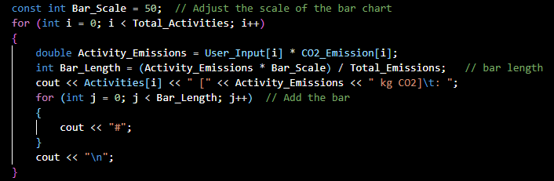
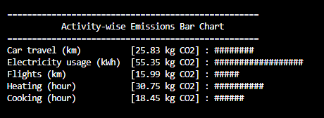
- Benefits:
  - Clarity: Users can easily identify activities with the highest emissions.
  - Engagement: The visual output makes the data more interactive and user-friendly.

CHAPTER 5: TESTING

5.1 Test Plan
The program was tested against various scenarios to ensure robustness:
- Valid inputs for all activities.
- Invalid inputs such as non-numeric values and negative numbers.
- Edge cases, including zero input and maximum possible input.

5.2 Test Cases
Test Case | Input | Expected Output | Result
Valid inputs | Car: 100, Elec: 50 | Correct emission calculations | Passed
Invalid input (string) | Car: abc | Error message: "Invalid input" | Passed
Negative input | Car: -10 | Error message: "Input cannot be negative" | Passed
Large emissions | Car: 10000 | AQI reaches max of 500 | Passed
Zero input | All: 0 | Total emissions = 0, AQI = 0 | Passed

Test Cast 1: Moderate Activity Level
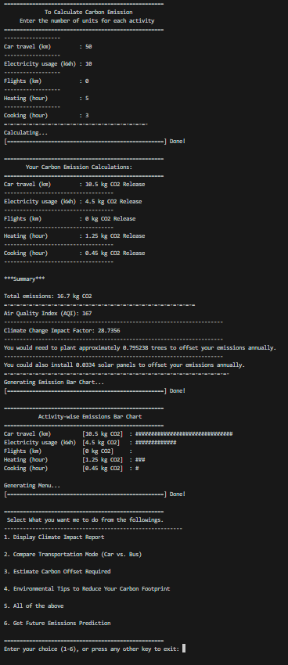
Test Cast 2: High Activity Level
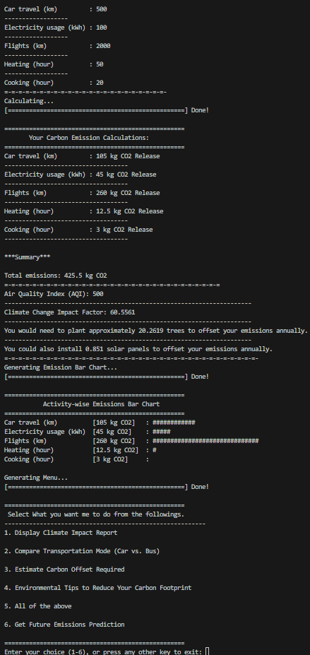
Test Cast 3: Low Activity Level
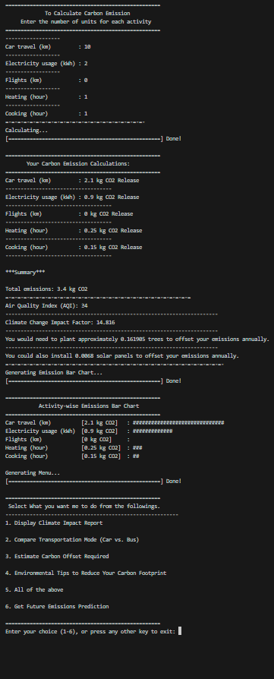
Test Cast 4: Zero Activity Level
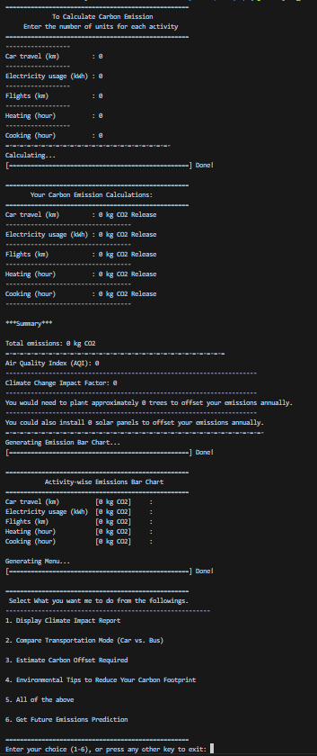
Test Cast 5: Extreme Activity Level
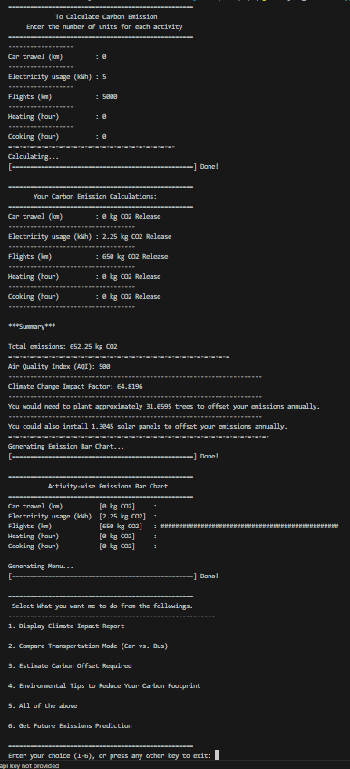
Test Cast 6: Negative Activity Level
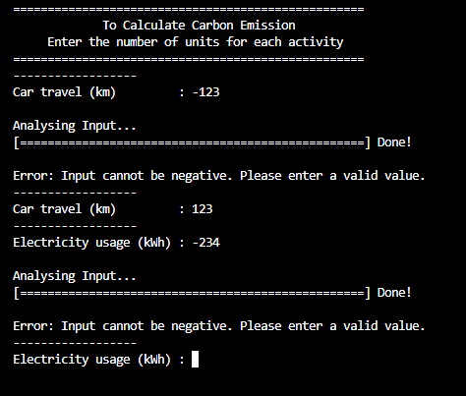
Test Cast 7: Activity Level (Input character)
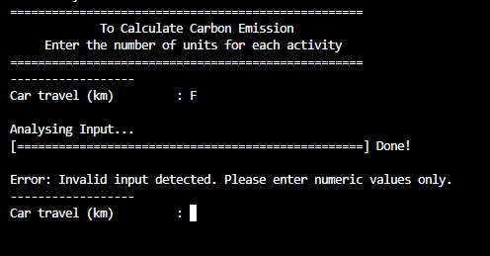

5.3 Results
All core functionalities performed as expected.

5.4 Error Handling
The program handles common errors like invalid input types and negative numbers efficiently. However, areas for improvement include:
- Handling extremely large inputs that might cause overflow errors.
- Providing more descriptive error messages for certain edge cases.

CHAPTER 6: USER INTERACTION FEATURES
The Climate Change Impact Calculator is designed with an interactive menu-driven interface, enabling users to explore various features seamlessly.

6.1 Menu Option
The program offers a wide range of options to suit different user needs, as displayed in the main menu:
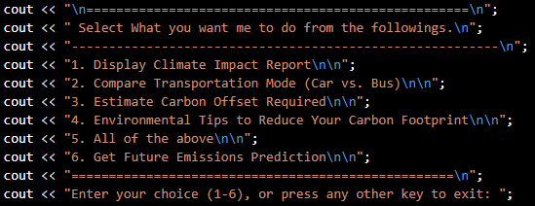
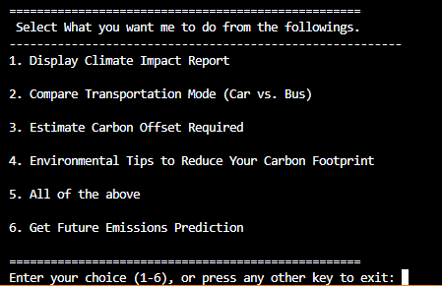
Each menu choice corresponds to a specific function:
1. Display Climate Impact Report
- Outputs total emissions, AQI, and climate impact factors.
- Provides activity-wise breakdown for user understanding:
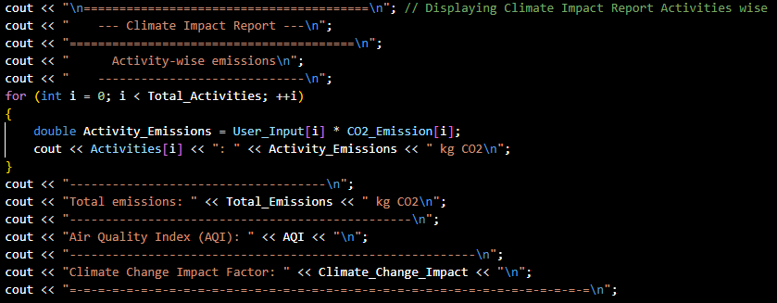
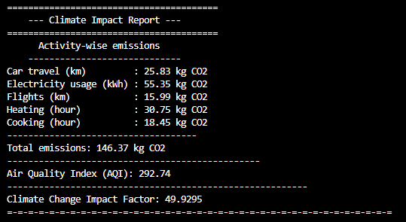
2. Compare Transportation Modes
- Demonstrates the benefits of choosing low-emission options like buses over cars
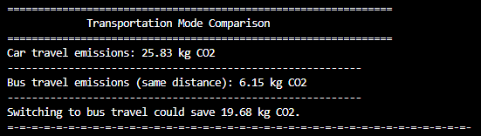
3. Estimate Carbon Offset Required
- Calculates trees or solar panels required to offset emissions:
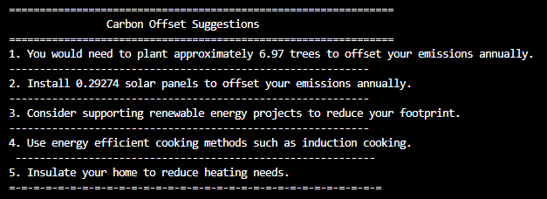
4. Provide Environmental Tips
- Offers actionable advice for reducing emissions:
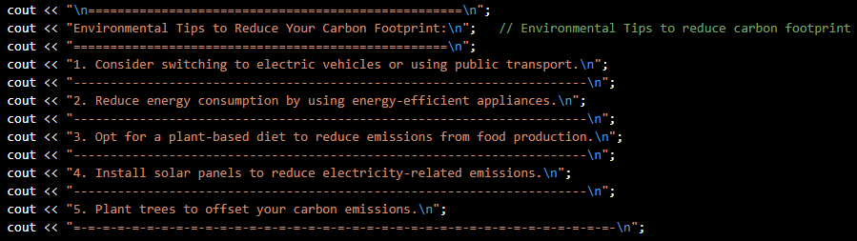
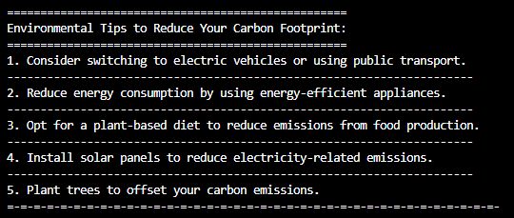
- Get Future Emissions Prediction
- Predicts future emissions based on current behavior:

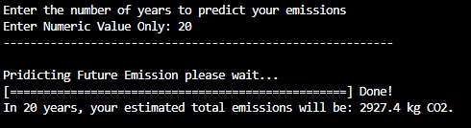
6. Process Bar
The Climate Change Impact Calculator includes a user-friendly, menu-driven interface. This menu allows users to navigate various features, such as viewing detailed climate reports, comparing transportation modes, and estimating carbon offsets.
To enhance user interaction, the program uses progress bars powered by the <thread> and <chrono> headers. These progress bars simulate real-time processing and provide feedback during operations like report generation, input validation, and file saving. For example, when a user enters invalid data, the program analyzes the input with a simulated progress bar, improving the overall user experience.
Usage of <thread> and <chrono>:
Progress Bars: The program simulates progress during lengthy tasks, such as calculating emissions or saving results to a file. This is achieved using std::this_thread::sleep_for to introduce delays.
Time Delays: Time intervals are defined with std::chrono::milliseconds, ensuring precise control over the duration of each delay.
Advantages for User Interaction:
The progress bars provide immediate feedback, keeping users informed about the status of tasks.
Time delays make the program feel more interactive and realistic, mimicking actual data processing.

6.2 File Saving
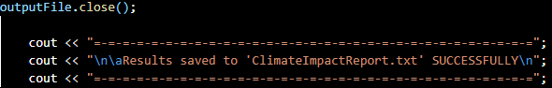
The program saves all calculated data and insights into a text file for future reference, ensuring users can revisit their results:
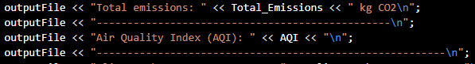
The program saves the results of calculations, reports, and visualizations into a text file. To improve user engagement, a progress bar indicates the file-saving process. This progress bar is implemented using std::this_thread::sleep_for and std::chrono::milliseconds to simulate real-time operations.
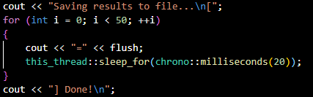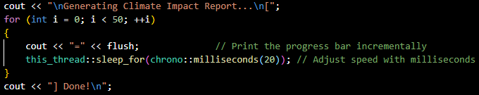
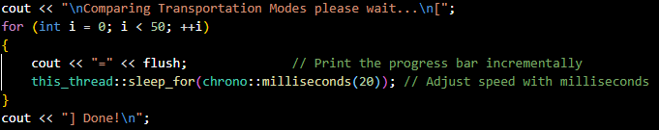
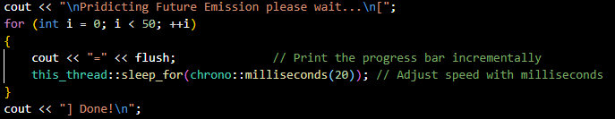

CHAPTER 7: ENVIRONMENTAL INSIGHTS
This chapter explores the program’s analytical and comparative capabilities, providing actionable insights into carbon emissions and sustainability.

7.1 Carbon Offset Calculation
The program calculates the number of trees or solar panels required to offset total emissions, making the concept of carbon neutrality more tangible:
These metrics help users quantify the steps needed to counteract their carbon footprint.

7.2 Comparison Insights
The program compares emissions across different transportation modes to highlight sustainable choices:
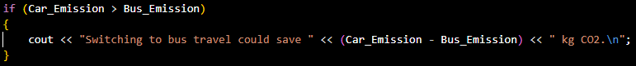
This promotes informed decision-making, demonstrating the environmental benefits of public transport.

CHAPTER 8: CHALLENGES AND LIMITATIONS

8.1 Challenges
Here are some challenges which we faced during program implementation.
During the development of the Climate Change Impact Calculator, several technical and logical challenges were encountered. Below is a detailed account of the problems faced and the strategies used to overcome them:
- Handling Invalid and Negative Inputs
  - Problem:
During initial testing, invalid inputs such as strings or negative numbers caused the program to crash. For example, entering text like "abc" instead of numeric input generated an error, and entering negative values caused logical inconsistencies.
  - Solution:
I implemented error-handling mechanisms using cin.fail() and conditional checks to validate input:
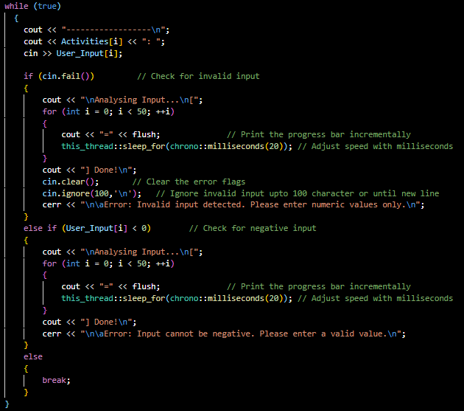
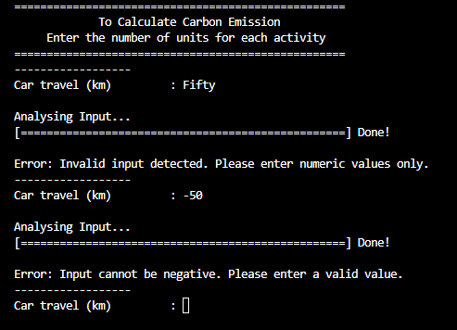
This ensured that the program only proceeded with valid, positive numeric inputs.
2. Scaling the Air Quality Index (AQI)
- Problem:
Initially, the AQI calculation used a simple linear formula, which led to unrealistic results for higher emissions. For example, very high emissions sometimes produced AQI values exceeding 500, which contradicts the standardized scale.
- Solution:
I revised the AQI calculation by introducing a tiered scaling system that adjusts the AQI based on emission ranges:
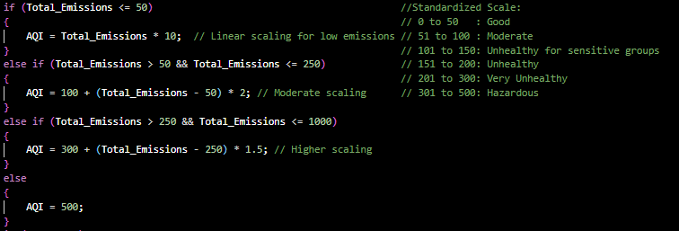
This solution provided a more accurate and realistic representation of AQI.
3. Bar Chart Visualization
- Problem:
The bar chart visualization initially lacked proportional scaling, which caused inconsistent and unreadable output for smaller emission values. For example, activities with minimal emissions would appear with no bars.
- Solution:
I added a scaling factor (Bar_Scale) to ensure proportional bar lengths relative to total emissions:
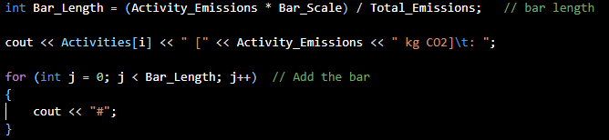
This adjustment ensured that every activity's contribution was visually represented, regardless of its size.
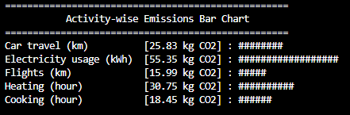
4. File Handling for Report Saving
- Problem:
During testing, the program sometimes failed to save reports to the file due to incorrect file handling or lack of permission.
- Solution:
I implemented proper file handling techniques and added error checks to confirm successful file operations: 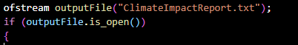 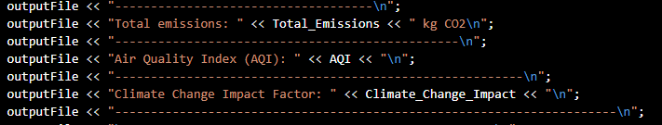 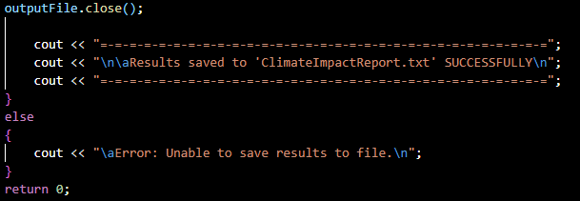
This ensured that results were saved consistently and provided feedback in case of failure.
5. Comparing Transportation Modes
- Problem:
Users often questioned the assumptions behind transportation mode comparisons, especially the constant emission factor for buses (0.05 kg CO2/km). This fixed value lacked flexibility for user-specific scenarios.
- Solution:
I added comments and structured the code to allow future integration of user-defined values. Currently, the program uses:
In the future, this value can be replaced with user inputs or real-time data sources.

8.2 Limitations
Despite the solutions implemented, the program has some inherent limitations:
- Fixed Emission Factors:
The program uses predefined constants for emissions (e.g., 0.21 kg CO2/km for car travel). These values may not represent all scenarios, such as different car models or fuel types.
- No Real-Time Data Integration:
The program cannot fetch real-time data from sensors or external sources, such as live electricity usage or fuel consumption.
- Simplistic AQI Calculation:
Although the AQI scaling is tiered, it does not account for localized pollution factors or seasonal variations.
- User Dependency:
The accuracy of the program depends on precise and truthful user input, which may introduce errors.
By addressing these challenges and limitations, the program successfully delivers accurate calculations and actionable insights while setting the foundation for future improvements.

CHAPTER 9: CONCLUSION

9.1 Summary
The Climate Change Impact Calculator provides a comprehensive and interactive approach to understanding carbon emissions. From detailed activity breakdowns to actionable recommendations, the program empowers users to take measurable steps toward sustainability.

9.2 Future Work
To improve and expand the program’s capabilities, the following enhancements are suggested:
- Integration with Real-Time Sensors:
Incorporate IoT devices to collect real-time data for electricity and fuel usage.
- Advanced Analytics:
Add features for lifecycle analysis and indirect emissions assessment.
- Mobile and Web Versions:
Develop a mobile or web-based interface for wider accessibility.
- Customizable Emission Factors:
Allow users to input specific values for vehicles, appliances, or local energy grids.

With these future enhancements, the Climate Change Impact Calculator aims to become an indispensable tool in the global fight against climate change, empowering individuals and organizations alike. These features not only enhance the user experience but also ensure the program’s practicality as a tool for promoting environmental responsibility and informed decision-making.

CHAPTER 10: APPENDIX

10.1 Full Program Code
The complete program code is provided below for reference. It includes all modules, logic, and functionalities described in this report.
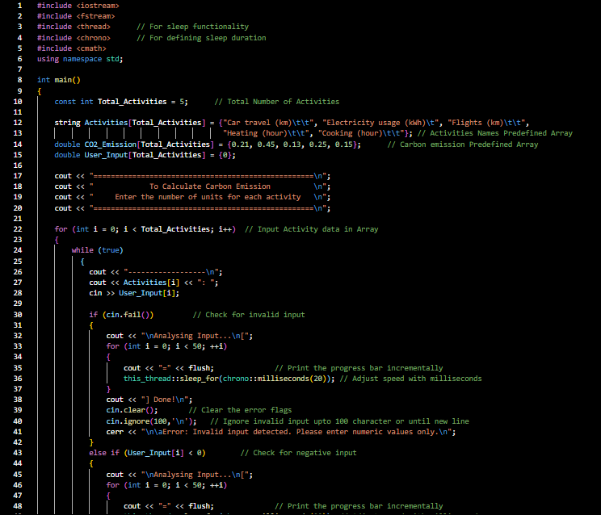

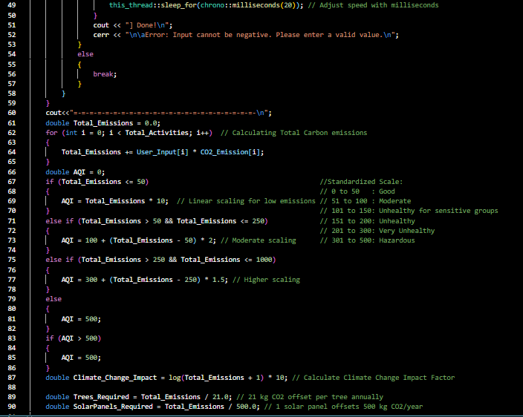
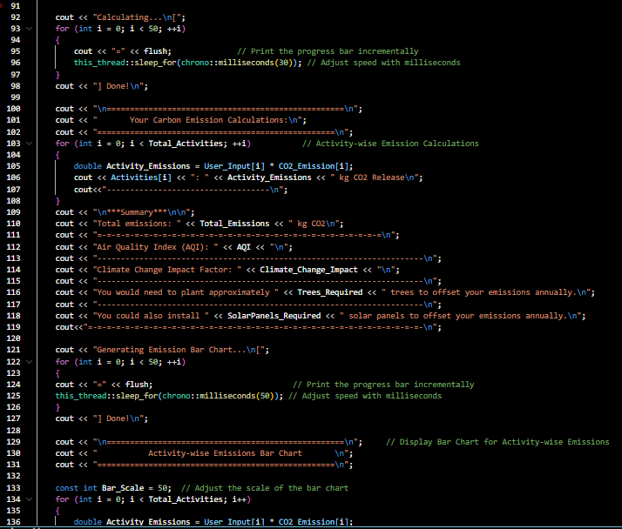

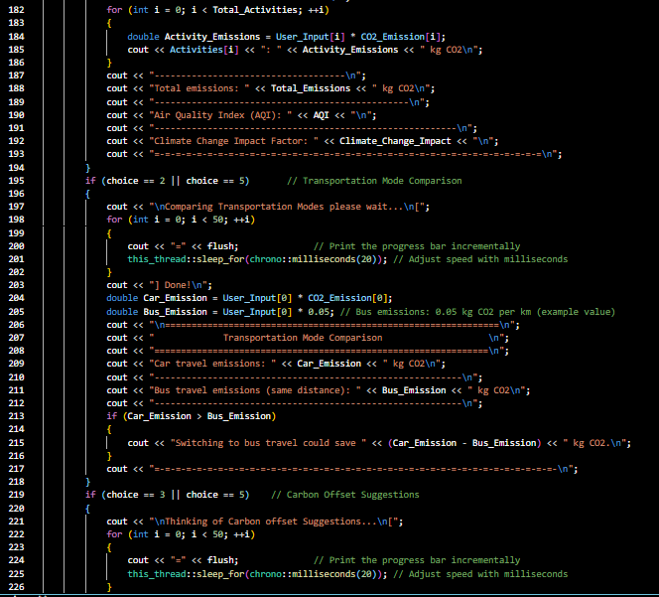
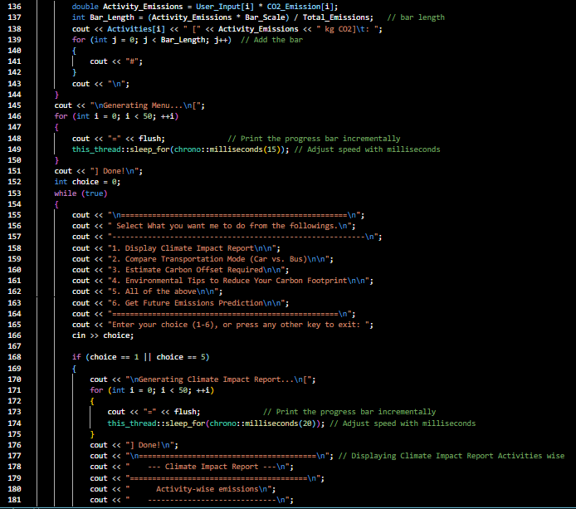
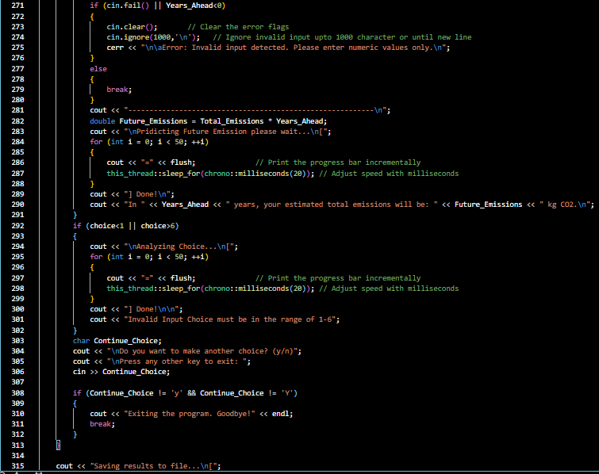
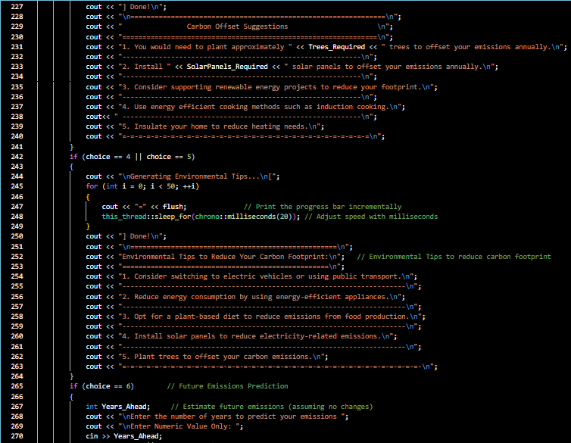
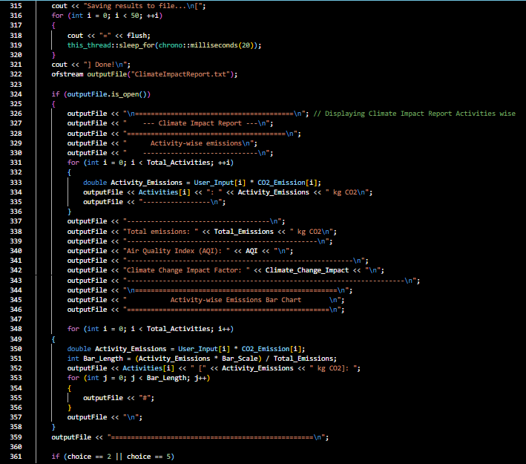
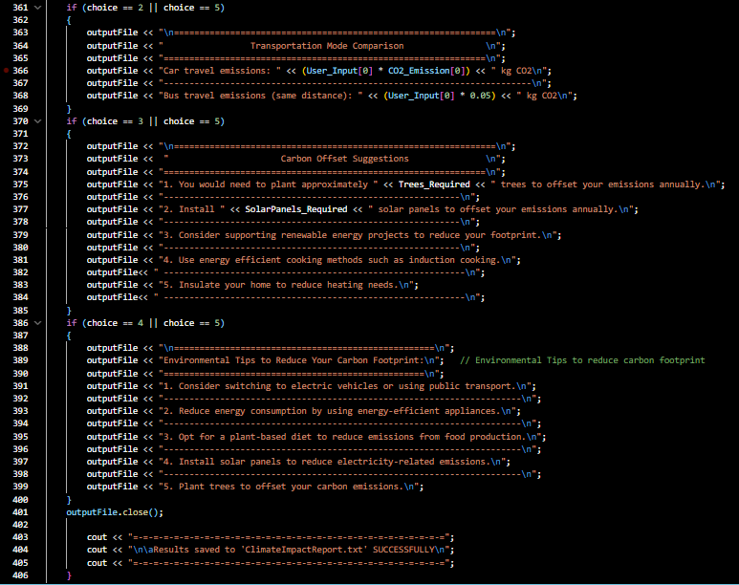
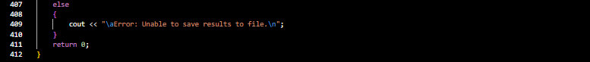

10.2 Sample Inputs and Outputs
This section provides example scenarios of user interactions with the program, showcasing its capabilities and output.
Sample Input:
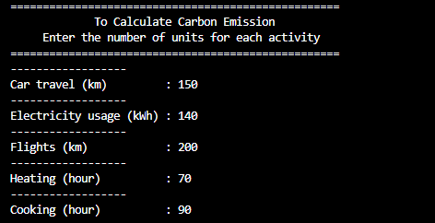
Sample Output:
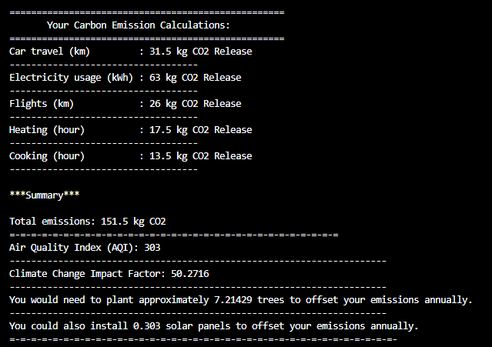
Bar Chart Output:
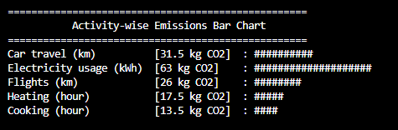

10.3 Formulas and Constants
1. CO2 Emissions Calculation
$$Emission=Activity Units×Emission Factor$$
Example
For car travel:
$$Emission=120km×0.21kg CO2/km=25.2kg CO2$$

2. Air Quality Index (AQI)
The AQI is calculated using a tiered scaling system:
- $AQI=Emission×Scalling Factor$
Scaling
$$0 - 50:Good \\ 51 - 100:Moderate \\ 101-150:Unhealthy for sensitive groups \\ 151-200:Unhealthy \\ 201-300:Very Unhelthy \\ 301-500:Hazardous$$
3. Climate Change Impact Factor
$$Impact Factor=\log\left(Total Emission+1\right) ×10$$
4. Carbon Offset Requirements
- Trees Required:
$$Trees=\frac{Total Emission}{21.0}(kg CO2/tress annually)$$

- Solar Panels Required:
$$Panals=\frac{Total Emission}{500.0}(kg CO2/panal annually)$$
5. Emission Factors
Activity | Emission Factor (kg CO2/unit)
Car travel (km) | 0.21
Electricity usage (kWh) | 0.45
Flights (km) | 0.13
Heating (hour) | 0.25
Cooking (hour) | 0.15

ACKNOWLEDGMENTS
“We would like to express our gratitude to our project supervisor, Sir Ghulam Ali, for his guidance and support throughout this project. Additionally, we appreciate the collaborative efforts of our team members in making this project successful.”

